***Assignment Part-2***

Playing with files

1. Create a file like **nano file1.txt**

o Edit some data and then save the file

1. Now we will copy date from file1 to new file2

# o cp file1.txt file2.txt

* Then see the output of file2.txt, **cat file2.txt**
* Give screenshot

Ans 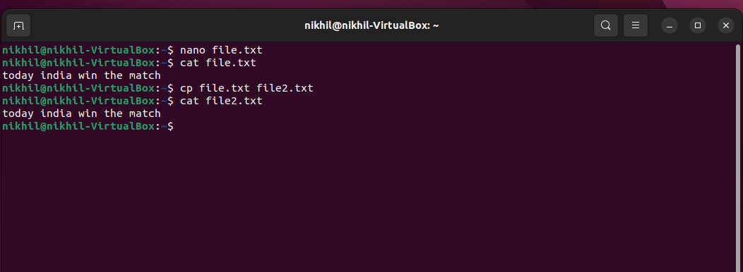

3. Now we will move the file2.txt to new folder **/home**

# mv file2.txt /home

* + Then go to **home** directory and check **ls,** file exits or not?
  + Given screenshot

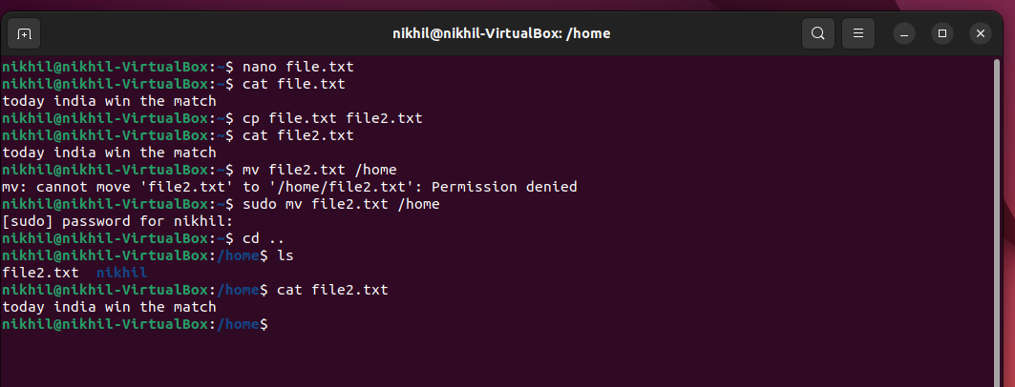

**4** .Then we create a new **file3.txt and file4.txt** in **home directory** and add content in it.

* + Now do **echo “Hello I am newline” > file3.txt** and provide the output of file3.txt
  + Now do **echo “Hello I am newline” >> file4.txt** and provide the output of file4.txt
  + Tell the different between both step you follow and the reason behind it

1. For remove a file or directory you can use the below two commands

* To delete a file – **rm <any filename**
* To delete a directory rmdir **<any filename >**

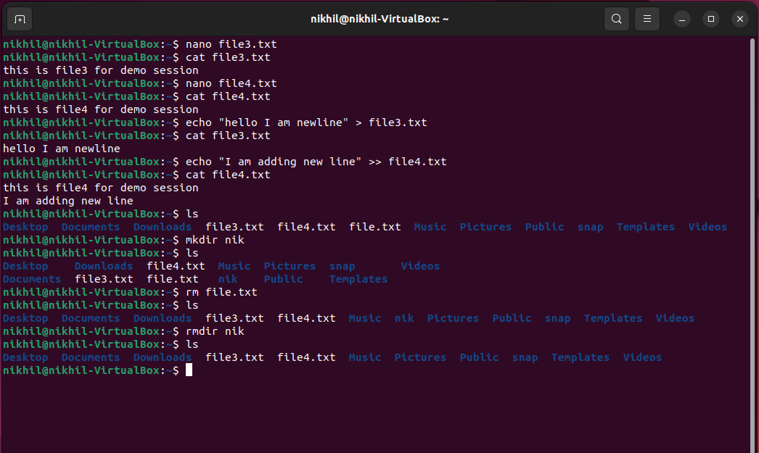

**Ans > means when we are using this single arrow we are replacing the data on file but when we are using >> this double arrow means we are adding the lines without any replacing the data on files**

**Ex = file 3 txt using = >**

**File 4txt using = >>**